TASK DIRECTORY, before you can chose a task you MUST BE assigned

# migrate dashboard to ventas

A migration means the “move” from the source Project to Procbel.Apps.XXX. Keeping in mind menú considerations, structure of new Project, naming conventions, and observance of MVVM pattern.

In this case the migration was an initial “migration” (later must be a refactoring) in order to acomodate the “submodules” and to create, for all the modules, some capabilities.

The migration from CRM.Modules.Dashboard to Procbel.Apps.Modules.Ventas.

The new modules can be reached from the main menú ventas link, and fills the submenuregion with the child modules as shown in the modulerelationship.png file as show here:

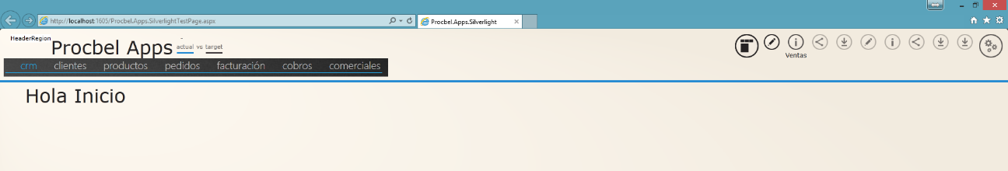

(remember about background and foregroud styles to acomplish with the palettechanges (check example at Shell.xaml ie Foreground="{StaticResource text}").

When the user passes the mouse over one of the Submenuregion links the menu should show the below options that are the submodules related (see again modulerelationship.png file. in that case when user moves the mouse over the crm menú the menú changes to:

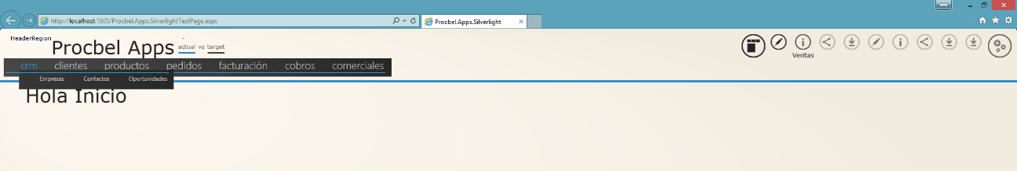

Also one of the capabilities that must be implemented and that should be used in all modules is the resize of main content. When the user click to show the right panel área the main content should be “listenning” to resize it’s content. If needed example i provide (but could be not the best solution)

# migrate dashboard to crm

A migration means the “move” from the source Project to Procbel.Apps.XXX. Keeping in mind menú considerations, structure of new Project, naming conventions, and observance of MVVM pattern.

In That case the migration is:

CRM.Modules.Dashboard -> Procbel.Apps.Silverlight.Modules.CRM

The main view should be the same as themain view of CRM.Modules.Dashboard

Other thing is that the submenu of crm that connects the submodules of CRM (the one that previously was appearing each time the user moves over the crm menú selection, this time is keeped in view and the crm submenú optioin is checked (show in checked state).

Must implement the resize when the right panel is shown and close.

# migrate companies to empresas

A migration means move the fucntionality and views from one Project to the other, keeping modularity and also MVVM and so on.

Please keep in mind the module relationship defined in file modulerealationships.png

The migration is:

CRM.module.companies to Procbel.Apps.Silverlight.Module.Empresas. The EF entities for this module are in Procbel.Apps.Models.CRM, the database creation are in CRMGenerationscript.sql and the repository Project is Procbel.Apps.Silverlight.Repository.

To the CRM module can be reached using the main module ventas submenú as shown in the picture:

The actual content of the CRM-Module.Companies submenú has to be moved to ModuleMenuRegion (please check silverlightannotations.docx). the place for this región is not clear actually but theri existence yes.

Remember to implment the resize content due to panel show close as explained before

s

# migrate contacts to contactos

same as migrate companies to empresas but with the Telerik CRM.Modules.Contacts module.

# migrate oportunities to oportunidades

same as migrate companies to empresas but with the Telerik CRM.Modules.Oportunities module.

# Create Procbel.Apps.Modules.Inicio

Thi is going to be the initial

MENU DISTRIBUTION:

AS shown in the .png module drawing. The main menu are composed by the orange nodes

Then each node shows in the submenu region their direct connexions.

In case of ventas:

CRM

Dashboard

Companies

Contacts

Opportunities

Activities

Clientes

Dashboard

Contacts

Activities

Proyects

Pedidos

(no submenu)

Facturacion

(no submenu)

Cobros

(no submenu)

Comerciales

Dashboard

Oportunities

Activities

Location

Productos

Dashboard

Oportunitites